**Booking System Notes**

**How Ticket Pricing works**

At the top level, we have the concept of "travellers", these are configurable in the database, so there can be as many or as few as we want. The list of travellers is what you see on the ticket selector for selecting Adult, Child etc. Travellers can be "guard only" so the selector for that traveller can be hidden on the interface from normal customers. You can also define the number of seats any given traveller needs, this allows us to sell dog tickets with having to allocate a seat to the dog, since a dog is defined as needing zero seats.

At the next level we have "ticket types", again defined in the database so we can put in what ever combination we require. Ticket types are not journey specific, they simply represent a type of ticket that could be sold for "a journey" but not necessarily all journeys (that is the next stage!). Each ticket type can be marked as guard only or for specials only, in order to exclude them from regular bookings. A ticket type has a composition of travellers, some will be a 1 to 1 relationship, so an Adult ticket type has a single adult traveller in it's composition, whereas a Family 2+2 has 2 Adult travellers and 2 Children. Ticket types can also have dependencies, so in order to be able to purchase it, you have to already have a qualifying ticket of another type in your selection. This ensures that the additional child ticket is only sold with Adults, Concessions or Family tickets. It also prevents unaccompanied dogs (unless the guard over rides). Ticket types also have a priority in the database, more on that further down!

The final part is the pricing table, again in the database so we can put in as many options as required, full flexibility here. The pricing table enables to set a price for a particular ticket type, so each entry will have a ticket type, a journey type aka single/return/round and the two stations the ticket is for, fares are assumed to be reciprocal, so you don't need to enter the reverse of any journey. Each entry will also have an online price and guard price against it and an image to be shown in the ticket selector. You do not have to enter a price for every possible combination of ticket type any journey, just the ones that are relevant.

So once the customer has chosen a journey and combination of travellers, the booking system will query the database to find all of the prices and ticket types that could be sold for that journey, regardless of the travellers chosen. It should be noted at this point that the list of travellers shown to the customer will only include those that are valid for the chosen journey, so if a concession ticket isn't available for the journey, the traveller type will not be shown.

The list of prices from the database will have been sorted according to the priority of the ticket type, so Family 2+2 will come first, followed by Family 1+1 etc. The pricing algorithm will compare the list of travellers chosen with the composition of the ticket type for each in turn working down the list in priority order to see whether or not it could be sold for that booking, if it can, the ticket is added to your selection, the algorithm then goes back to the top of the price list and works down it again for the remaining ticket less travellers until everybody has a ticket.

The ticket priority system works as a short cut to simplify the process of choosing tickets, since as long as you correctly prioritise the ticket types and your fare structure isn't so complicated as to prevent this approach from working, you will always arrive at the best price for any given combination of travellers without having to test every possible combination of tickets. Testing every combination is really difficult to do since you have to have an algorithm that can compare any given set of travellers with the available ticket types to work out every combination, that is not easy to write and could take days of effort to get right. Hence the short-cut.

**Editing Train Formations**

All the configuration for a given operating day is part of the “Bookable Day” menu. Here you can edit all the parameters that apply to that days services. Navigate to the bookable day section and click edit against the date you wish to set up or edit.

The first part of the page gives you some basic parameters which can be set up.

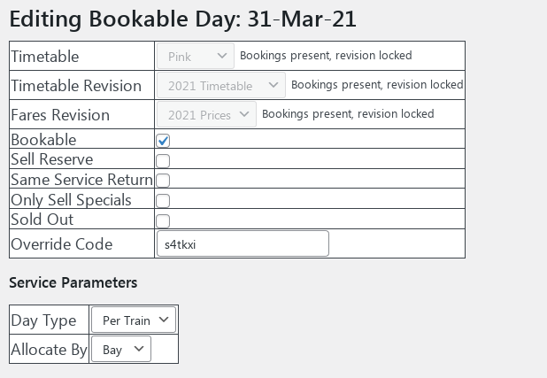Options:

* Timetable: The chosen timetable for the day.
* Timetable Revision: The timetable revision used for this day.
* Fares Revision: The fares revision used for this day.
* Bookable: Tick this to allow tickets to be booked for this day. Tickets cannot be bought online for dates in the past, so this will only apply for the current date going forward.
* Sell Reserve: Every service has a reserve that isn’t bookable, this is to allow the correct train formation to be entered, but some seats or bays held back until you are confident that coaches won’t have to be withdrawn or re-arranged. Tick this box to put the reserve for this day on sale. The size of the reserve for any given service is configured further down.
* Same Service Return: this forces all customers to book only return tickets, returning on the same service they went out on.
* Only Sell Specials: If you want to put tickets for specials on sale ahead of regular service trains, tick this.
* Sold Out: This will close all online ticket sales regardless of whether the trains are full, but will continue to allow guards bookings.
* Override code: This is the code that can be issued to customers by the guard who wish to book a late running or nominally full service on line. Should only be used on the day with the train in the station!

Note, the timetable, timetable revision and fares revision can only be changed if there are no live bookings against a day. In future there will be an override for this and tools to allow bookings to be re-assigned if the timetable has to change for operational reasons.

Service Parameters:

* Day Type. There are two ways to set up the train formations for a day, depending on the nature of the timetable.
  + Simple: A Simple day assumes that every service that operates uses the exact same set of coaches. Using this day type means that coach sets don’t have to be allocated to individual departures.
  + Per Train: This allows for 2 or more sets of coaches to be configured and then allocated individually to departures from each terminal. It is assumed that coach sets aren’t reconfigured once the train has left the terminal!
* Allocate By: There are two ways of allocation seating on the train, either by Bay where each booking gets a bay or bays for their exclusive use, or seat where the total seating capacity of the train (minus an overhead) is used with passengers potentially sharing bays.

**Coaches**

All coaches are pre-configured in the system with the correct bays and seta totals. Coaches are then added to sets to make up the final train formation.

**Coach Sets**

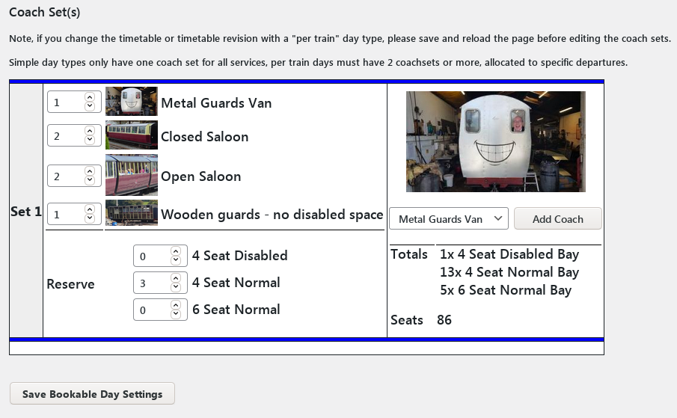

Coach sets are made up by adding or removing pre-configured coaches with a known number of seats or bays to a set of coaches that is then used for that days services. The above screenshot shows a single set for a “simple” day. The top left of the set shows the coaches currently in the set and how many of them there are. To add a coach, select the desired coach from the list in the top right box and click “Add Coach”. To remove a coach entirely from the set, simply sets its number to 0 using the number selector against the coach and it will be taken out.

The seating reserve associated with the set can be set on the bottom right, this represents the number of seats or bays that will be held back from sale for this set until the reserve is put on sale. The selectors here will only show bay types that are available in the selected coaches and the reserve you can set will be constrained to the maximum number of bays of that type available.

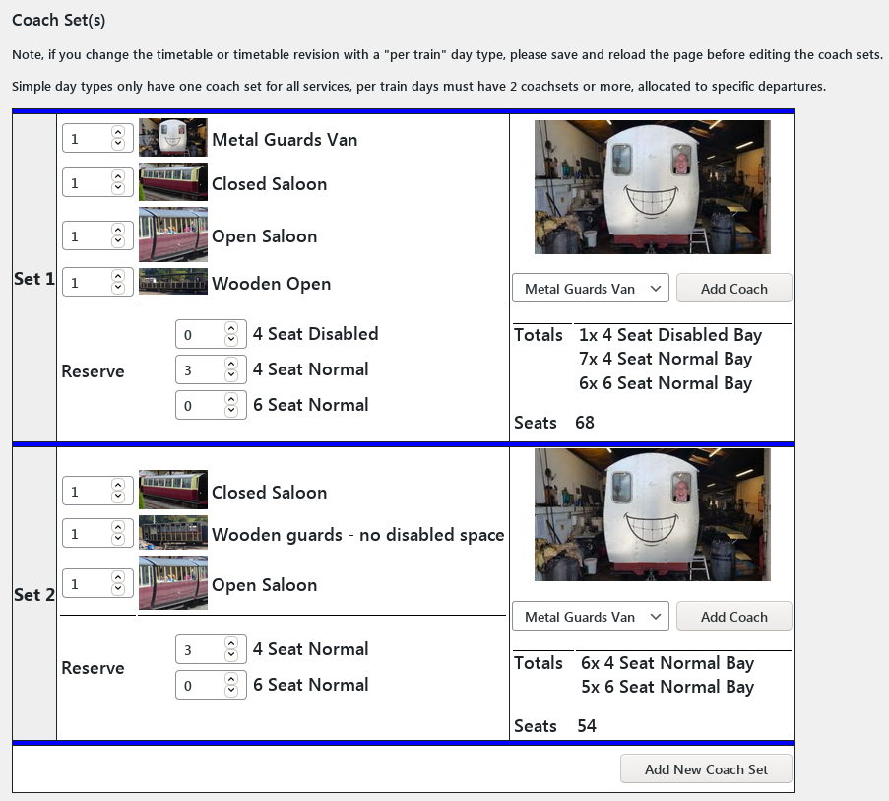

Above is a coach set editor for a “per train” day type, this shows the minimum of two sets that are needed for this day type. More sets can be added as required, sets can also be deleted but that option is only available if you have 3 or more sets configured in order to ensure that there are always 2 sets.

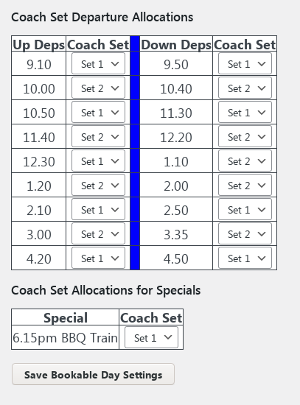

Above is the Coach set departure allocation, here you allocate a set of coaches to each departure from the two terminals.

Specials are also shown here so a coach set can be allocated.

**WARNING:** At present you will not be warned if a coach set is edited for a day with existing bookings and insufficient capacity is present in the new coach set for the existing bookings. You should confirm any such changes by checking the guard's interface.

When saving a Bookable day you will also have to option to save the coach set configuration as the default for that timetable type, so that details do not need to be re-entered. When saving a default it is best to only do so for a day that has a full set of services running for that timetable, aka not one with a “Not Mondays” departure.

Near the bottom of the page, there is a button “Show service parameter data”, this makes the data structure that is generated by the coach set editor visible so it can be checked for accuracy. Do not touch unless you really know what you are doing.

There is also a delete function to allow the bookable day to be removed entirely. This can only be used if there are no bookings.